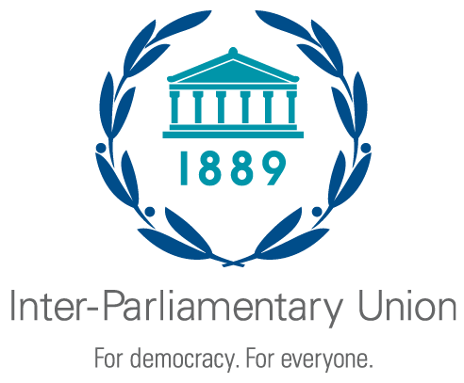

Third Regional Seminar for the Asia-Pacific Region Parliaments on
Achieving the Sustainable Development Goals

Islamabad (Pakistan), 13 - 14 September 2022

Organized jointly by the Inter-Parliamentary Union
and the National Assembly of Pakistan
REGISTRATION FORM

(one form per participant)

To be returned no later than 30 August 2022

Country
Mr. / Ms.
First name |  |  | Family name
Parliament / Chamber
Function | Member of lower chamber or unicameral parliament | Member of upper chamber |  | Aide or staff
Full title
E-mail
Telephone

[For parliamentarians only]
Please list up to three parliamentary committees to which you belong
1:
2:
3:

Travel Details:

Arrival date |  | Flight No. |  | Arrival time
Departure date |  | Flight No. |  | Departure time

Date: |  | Signature:

Please return this form to:

Mr. Tahir Hussain  Secretary  National Assembly of Pakistan  Parliament House  Constitution Avenue  ISLAMABAD 44000  Pakistan  Secretariat of the Seminar  Tel: +92519212431  Fax: +92519212432  e-mail: secretary@na.gov.pk; waseemiqbal723@gmail.com  With copy to:  Tel: +92519103114  Fax: +92519103213  e-mail: ir.diplo@gmail.com; salmajoveria@gmail.com; alisa.khan.82@gmail.com | With copy to:  Inter-Parliamentary Union  Chemin du Pommier 5  C.P. 330  1218 Le Grand-Saconnex  GENEVA  Switzerland  Tel: +41 22 919 4150  Fax: +41 22 919 4160  e-mail: postbox@ipu.org

