IPU PARLIAMENTARY MEETING AT COP29
ARRIVAL, DEPARTURE & ACCOMODATION FORM
THE MILLI MAJLIS
OF THE REPUBLIC OF AZERBAIJAN
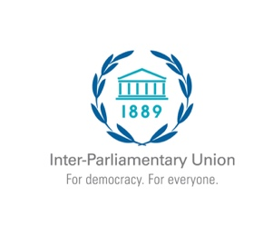
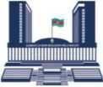



DELEGATION OF:
Please note that flight bookings and local transportation, including airport transfers are the responsibility of delegations. As stated in the invitation letter, the IPU and Milli Majlis of the Republic of Azerbaijan are not able to support logistical arrangements.
# | FULL NAME | DESIGNATION / JOB TITLE | PASSPORT NO. | ARRIVAL DATE  DD/MM/YY | DEPARTURE DATE  DD / MM / YY | ACCOMMODATION (Hotel/Apartment  and address)
1
2
3
4
5
6
7
8
9
10
11
12
13
14
15
16
17
18
19
20

Please fill out this form electronically
Please return this request form to international@meclis.gov.az no later than 5 November 2024

