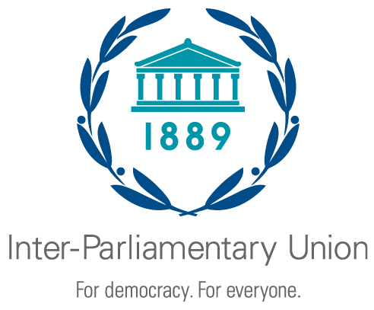 |   South Asian Speakers’ Summit on Achieving  the Sustainable Development Goals  Promoting regional parliamentary cooperation for sustainable, equitable  and green economic growth
Colombo (Sri Lanka), 11-12 July 2018

Organized by the Inter-Parliamentary Union (IPU) and the Parliament of Sri Lanka

REGISTRATION FORM
(one form per participant)

To be returned no later than 10 June 2018

Country
Ms. Mr.
First name |  |  | Family name
Parliament / Chamber
Function | Speaker of Parliament | MP or Senator |  |  | Aide or staff
Full title
E-mail
Telephone

Arrival date |  | Flight No. |  | Time of arrival
Departure date |  | Flight No. |  | Time of departure

Date: |  | Signature:

Please return this form to:

Sri Lankan Inter-Parliamentary Group  Parliament  Parliament House  SRI JAYEWARDENEPURA, KOTTE  Sri Lanka  Telephone: +94112777277  Fax No. +94112777275  Email: cpa@parliament.lk |  | Inter-Parliamentary Union  Chemin du Pommier 5, Case postale 330  1218 Le Grand-Saconnex  Geneva, Switzerland  Telephone: +41 22 919 41 50 / Fax: +41 22 919 41 60  Email: postbox@ipu.org

