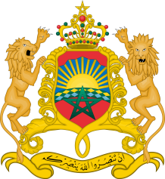
Kingdom of Morocco
Parliament

Parliamentary Meeting on occasion of the Adoption of the Global Compact for Safe, Orderly and Regular Migration

Organized jointly by the Inter-Parliamentary Union and the Parliament of the Kingdom of Morocco

6 - 7 December 2018, Rabat (Morocco)

REGISTRATION FORM

[One form per participant]

COUNTRY

Ms. Mr.
FAMILY NAME: |  | FIRST NAME:
Address:
City: |  |  | Country:
Telephone: |  |  | Mobile:

Parliament / Chamber:
Function: | Member of Parliament | Senator | Aide or staff
Full title:
Office E-mail:
Personal E-mail:

Date of arrival: |  | Flight No.: | Time of arrival:
Date of departure: |  | Flight No.: | Time of departure:

DATE |  | SIGNATURE

Kindly return this form to:

With a copy to:

Mr. Said SATRAOUY  Head, Division of International  Relations and Cooperation  House of Representatives  Kingdom of Morocco  Tel: +212 537 67 96 56  Fax: +212 537 67 97 91  Email: satraouy@parlement.ma | Mr. Rogier HUIZENGA  Human Rights Programme Manager  Inter-Parliamentary Union  Geneva  (Switzerland)  Tel.: + 41 22 919 41 24  Fax: + 41 22 919 41 60  Email: rh@ipu.org / postbox@ipu.org

