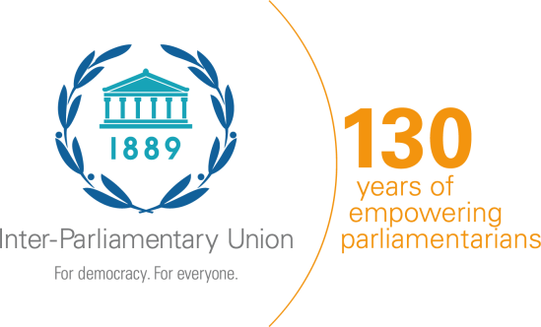
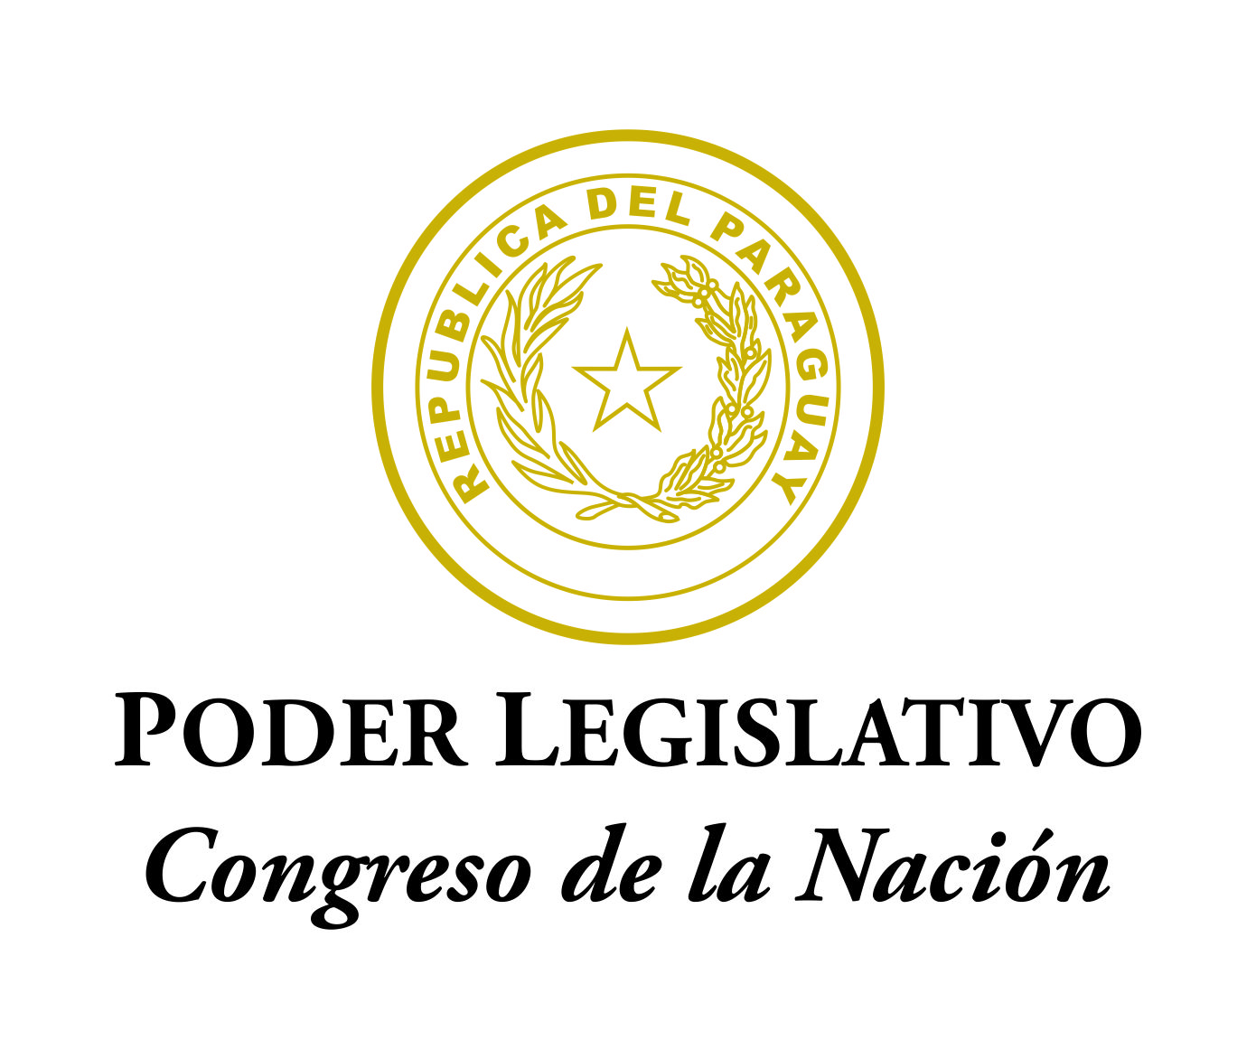
Sixth IPU Global Conference of Young Parliamentarians

9-10 September 2019, Asuncion (Paraguay)

One form per participant
Registration Form
Country |  | Click here to enter tex
Name | Mr.☐  Ms.☐ | First |  | Middle (if any) |  |  | Surname
 |  | Click here to enter text |  | Click here to enter text |  |  | Click here to enter text
Date of Birth (dd/mm/yyyy) |  | Click here to enter text
Parliament (Chamber)/  Organization |  | Click here to enter text
Function |  | Member of Parliament / Senator ☐ |  |  |  | Aide or staff ☐
 |  | Other ☐: Click here to enter text
Full title |  | Click here to enter text.
Type of Passport |  | Diplomatic ☐ | Official ☐ |  | Ordinary ☐ |  | Other ☐:Click here to enter text
Passport No. |  | Click here to enter text |  |  | Nationality |  | Click here to enter text
Office e-mail Address |  | Click here to enter text
Personal e-mail Address |  | Click here to enter text
Telephone |  | Click here to enter text
Date of arrival and flight number |  | Click here to enter text
Date of departure and flight number |  | Click here to enter text
Dietary restrictions |  | Vegetarian YES ☐ NO ☐

Date: | Click here to enter text

Please return this form to the addresses below no later than 21 August 2019. If a visa upon arrival is also needed, please include a scanned copy of the information page of your passport.

Inter-Parliamentary Union  e-mail: postbox@ipu.org | Congress of Paraguay  e-mail: protocolohcs@gmail.com

