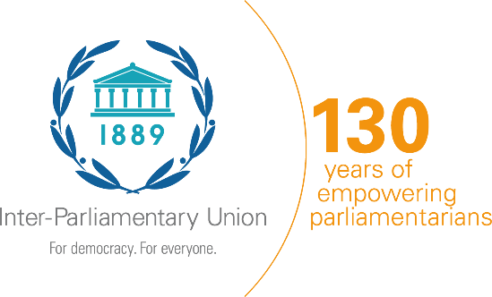

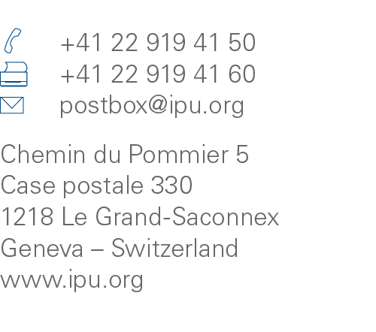

Data on committee chairpersons

Part of the data collected and published in the IPU’s Parline database contributes to global monitoring of the Sustainable Development Goals (SDGs). In particular, SDG targets 5.5 and 16.7 focus on parliament’s central role in fostering responsive, inclusive, participatory and representative decision-making.

Based on the updates provided through New Parline, the IPU annually reports data on the sex and age of the Speakers, members and chairpersons of the defence, finance, foreign affairs, gender equality and human rights committees to the United Nations.
This reporting exercise is part and parcel of monitoring progress toward the 2030 Agenda for Sustainable Development and is used to ascertain the representation of women and young people in decision-making positions in parliament.

COUNTRY:
Chamber: | ☐ Lower house / Unicameral  ☐ Upper house
Name of the person completing
the questionnaire:

Parline Correspondent? | ☐ Yes ☐ No
Job title:
e-mail:
Telephone:
Date:

Information about the chairpersons of the following parliamentary committees
- Please check "Not applicable" if one or more of the committees listed below does not exist.
- Choose and report information on the chairperson of the committee with the primary mandate to cover each topic.
- If a committee is co-chaired, please provide information about the first chair in the table and the same set of data for the second chair in the notes section.
- If a committee maintains dual or multiple portfolios – e.g. "Committee on Defence and Foreign Affairs" – provide the name of the committee in the notes section.
- For bicameral parliaments: Fill out the table below for the first chamber and use the table on the following page for the other chamber. Please also specify if any of the committees listed are joint.
Committee | Name of committee chairperson  (First name, Family name) | Date of birth  (DD/MM/YYYY) | Sex  (male, female) | Political affiliation  (majority, opposition, independent) | Was the same person already the chair of the same committee in the previous legislature? | Joint? (for bicameral parliaments only) | Not applicable
Foreign affairs |  |  | ☐ Male  ☐ Female | ☐ Majority  ☐ Opposition  ☐ Independent | ☐ Yes  ☐ No | ☐ | ☐ N/A
Defence |  |  | ☐ Male  ☐ Female | ☐ Majority  ☐ Opposition  ☐ Independent | ☐ Yes  ☐ No | ☐ | ☐ N/A
Finance |  |  | ☐ Male  ☐ Female | ☐ Majority  ☐ Opposition  ☐ Independent | ☐ Yes  ☐ No | ☐ | ☐ N/A
Human rights |  |  | ☐ Male  ☐ Female | ☐ Majority  ☐ Opposition  ☐ Independent | ☐ Yes  ☐ No | ☐ | ☐ N/A
Gender equality |  |  | ☐ Male  ☐ Female | ☐ Majority  ☐ Opposition  ☐ Independent | ☐ Yes  ☐ No | ☐ | ☐ N/A

Notes:
***** FOR BICAMERAL PARLIAMENTS ONLY *****

Second chamber: | ☐ Lower house / Unicameral ☐ Upper house

Information about the chairperson of the following parliamentary committees
- Please check "Not applicable" if one or more of the committees listed below does not exist.
- Choose and report information on the chair of the committee with the primary mandate to cover each topic.
- If a committee is co-chaired, please provide information about the first chair in the table and the same set of data for the second chair in the notes section.
- If a committee maintains dual or multiple portfolios – e.g. "Committee on Defence and Foreign Affairs" – provide the name of the committee in the notes section.
Committee | Name of committee chairperson  (First name, Family name) | Date of birth  (DD/MM/YYYY) | Sex  (male, female) | Political affiliation  (majority, opposition, independent) | Was the same person already the chair of the same committee in the previous legislature? | Joint?  (for bicameral parliaments only) | Not applicable
Foreign affairs |  |  | ☐ Male  ☐ Female | ☐ Majority  ☐ Opposition  ☐ Independent | ☐ Yes  ☐ No | ☐ | ☐ N/A
Defence |  |  | ☐ Male  ☐ Female | ☐ Majority  ☐ Opposition  ☐ Independent | ☐ Yes  ☐ No | ☐ | ☐ N/A
Finance |  |  | ☐ Male  ☐ Female | ☐ Majority  ☐ Opposition  ☐ Independent | ☐ Yes  ☐ No | ☐ | ☐ N/A
Human rights |  |  | ☐ Male  ☐ Female | ☐ Majority  ☐ Opposition  ☐ Independent | ☐ Yes  ☐ No | ☐ | ☐ N/A
Gender equality |  |  | ☐ Male  ☐ Female | ☐ Majority  ☐ Opposition  ☐ Independent | ☐ Yes  ☐ No | ☐ | ☐ N/A

Notes:

