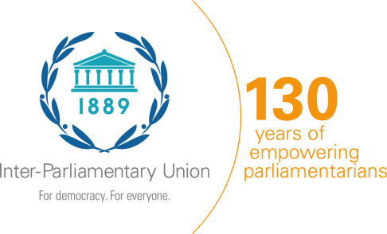

Engaging parliaments on the promotion of human rights including on the work of the Human Rights Council and its Universal Periodic Review (UPR)

Virtual workshop for committees in charge of human rights of the Parliaments of Africa, Europe, the Caribbean and Canada, and Members of the Commonwealth, organized by the Inter-Parliamentary Union (IPU), the Commonwealth Secretariat (ComSec) and the Office of the United Nations High Commissioner for Human Rights (OHCHR).

Two half-days spread over two days, Monday, 13 - Tuesday, 14 July 2020

REGISTRATION FORM

[One form per participant]

COUNTRY

Ms. |  | Mr.
FAMILY NAME: |  |  |  |  | FIRST NAME:
Address:
City: |  |  |  |  |  | Country:
Telephone: |  |  |  |  |  | Mobile:

Parliament / Chamber:
Function: | Member of Parliament |  | Senator |  | Aide or staff
Full title:
Office E-mail:
Personal E-mail:

DATE |  | SIGNATURE

Kindly return this form to the following addresses as soon as possible. Thank you in advance:

With copy to:
Inter-Parliamentary Union  Chemin du Pommier 5  Case postale 330  1218 Le Grand-Saconnex/Geneva  (Switzerland)  Mr. Akiyo AFOUDA  Human Rights Officer  Tel.: + 41 22 919 41 24  Fax: + 41 22 919 41 60  Email: aa@ipu.org; hrteam@ipu.org;  postbox@ipu.org | Office of the United Nations High Commissioner for Human Rights (OHCHR)  Palais Wilson, 52 rue des Pâquis  1201 Geneva (Switzerland)  Ms. Tigest DESTA  Tel.: +41 22 928 91 76  Email: tdesta@ohchr.org  Ms Daniela DOSSEVA  Tel.: +41 22 917 35 53  Email: ddosseva@ohchr.org

